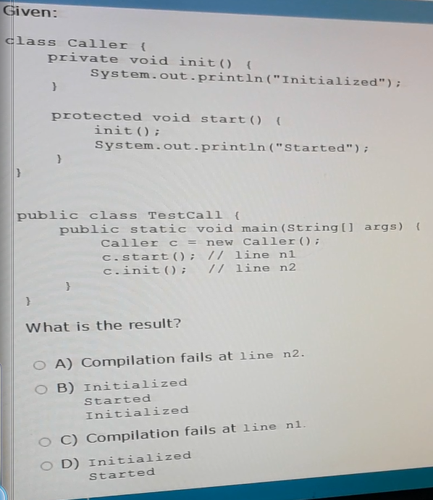Problems_1:

ackage vendorexam.que_1;

/**

*

* @author Touhid

*/

class Caller{

private void init(){

System.out.println("Initialized");

}

protected void start(){

init();

System.out.println("Started");

}

}

public class Testcall {

public static void main(String[] args) {

Caller c=new Caller();

c.start(); //line 11

c.init(); //line 2

}

}

Ans: A

Problem 2:

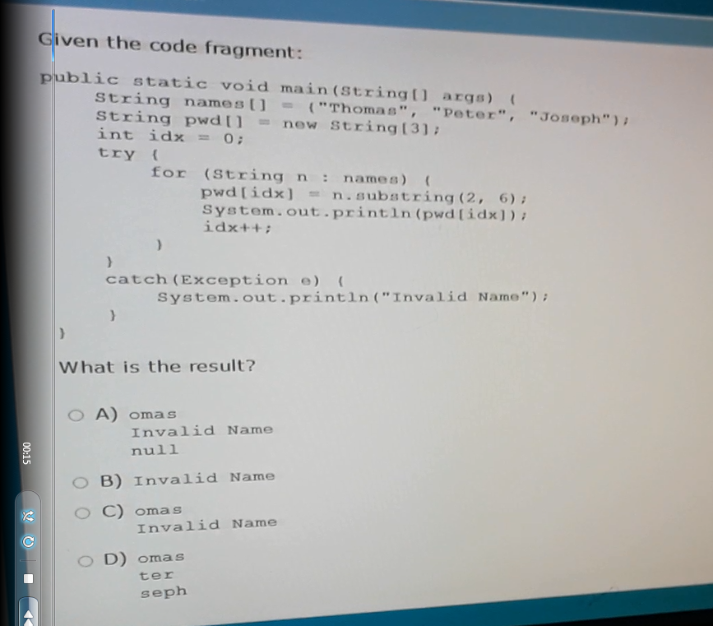

package vendorexam.que_2;

/**

*

* @author Touhid

*/

public class Test {

public static void main(String[] args) {

String names[]={"Thomas","Peter","joseph"};

String pwd[]=new String[3];

int idx=0;

try{

for (String n: names) {

pwd[idx]=n.substring(2,6);

System.out.println(pwd[idx]);

idx++;

}

}

catch(Exception e){

System.out.println("Invalid name");

}

}

}Ans: C

Problem 3:

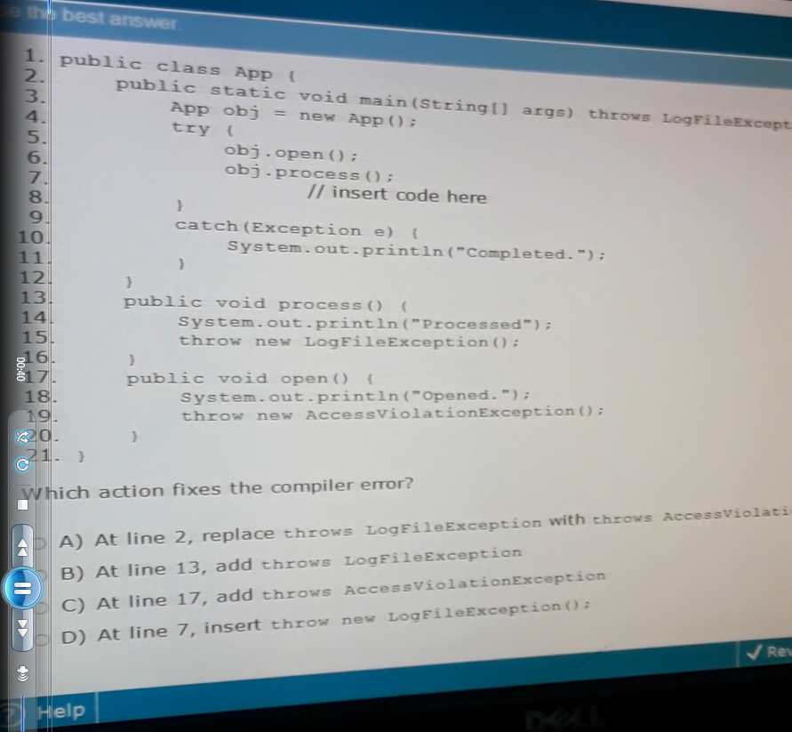

package vendorexam.que_3;

public class App {

public static void main(String[] args) throws LogFileException {

//a throws AccessViolationException

App obj = new App();

try{

obj.open();

obj.process();

//insert code here

// d throw new LogFileException();

}

catch(Exception e){

System.out.println("Completed.");

}

}

public void process() { // b trows LogFileException {

System.out.println("Processed");

throw new LogFileException();

}

public void open() throws AccessViolationException {

System.out.println("Opened.");

throw new AccessViolationException();

}

}

Ans: Problem.

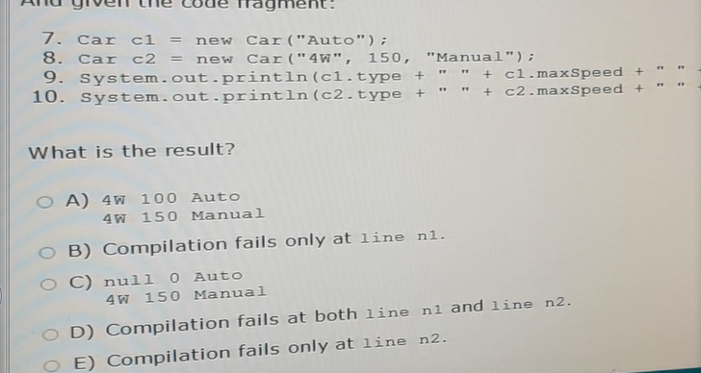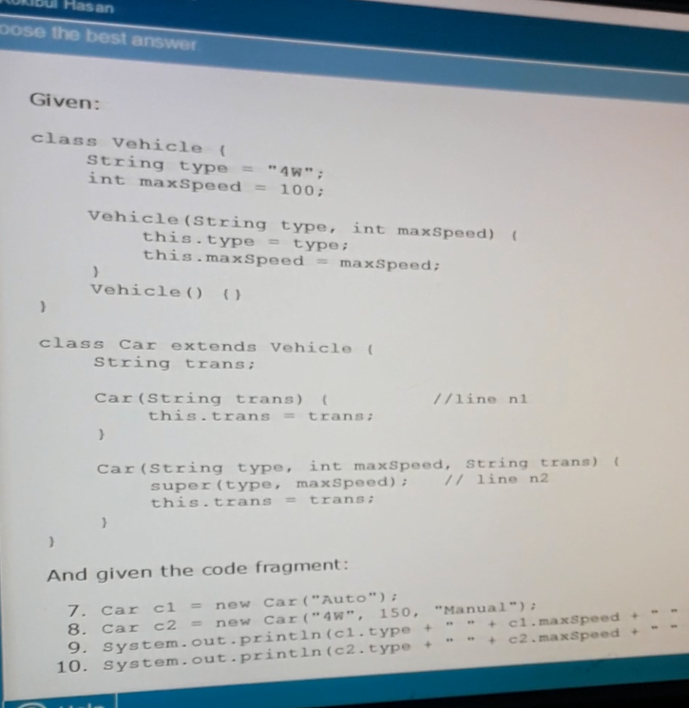Problem: 4

package vendorexam.que_4;

class Vehicle {

String type = "4w";

int maxSpeed = 100;

public Vehicle(String type, int maxspeed) {

this.type = type;

this.maxSpeed = maxspeed;

}

Vehicle() {

}

}

class Car extends Vehicle {

String trans;

Car(String trans) { // line 1

this.trans = trans;

}

Car(String type, int maxSpeed, String trans) {

super(type, maxSpeed); //line 2

this.trans = trans;

}

}

public class Test {

public static void main(String[] args) {

Car c1 = new Car("Auto");

Car c2 = new Car("4w", 150, "Manual");

System.out.println(c2.type + " " + c2.maxSpeed +" "+c2.trans);

System.out.println(c1.type + " " + c1.maxSpeed +" "+c1.trans);

}

}

Ans: A

Problem 5:

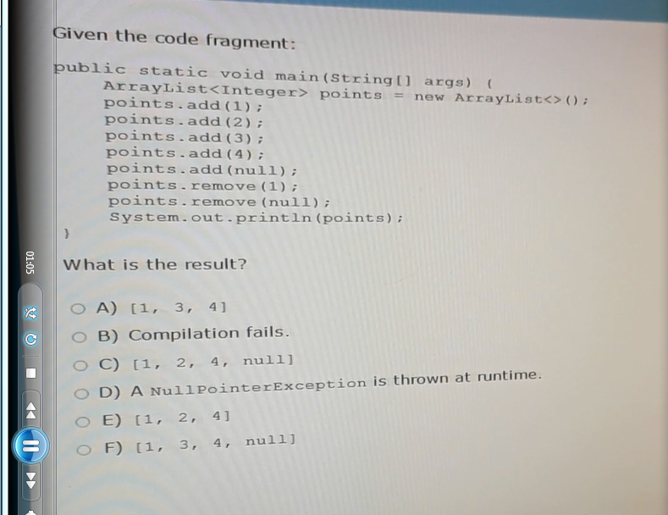

package vendorexam.que_5;

import java.util.ArrayList;

/**

*

* @author Touhid

*/

public class Test {

public static void main(String[] args) {

ArrayList<Integer> points =new ArrayList<>();

points.add(1);

points.add(2);

points.add(3);

points.add(4);

points.add(null);

points.remove(1);

points.remove(null);

System.out.println(points);

}

}

Ans: A

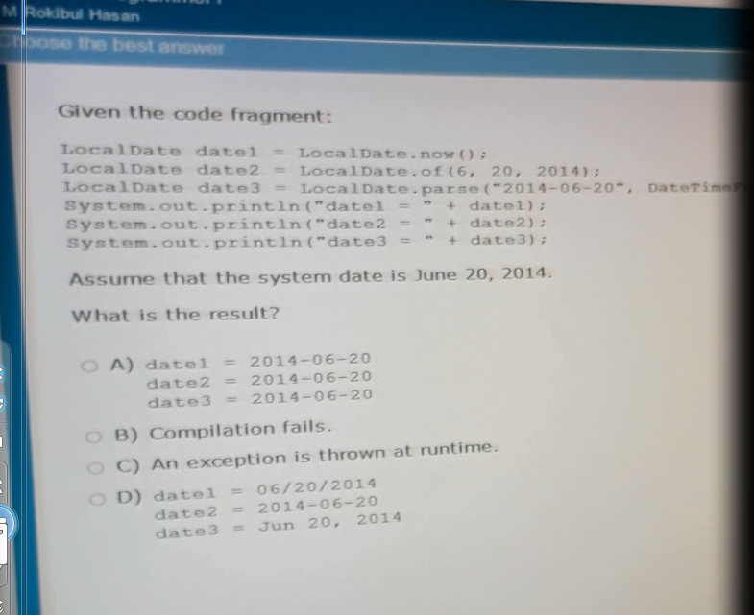Problem 6:

public class Test {

public static void main(String[] args) {

LocalDate date1 = LocalDate.now();

LocalDate date2 = LocalDate.of(6, 20, 2014);

//LocalDate date3 = LocalDate.parse("2014-06-20" DateTimeFormatter);

System.out.println("date1= " + date1);

System.out.println("date2= " + date2);

// System.out.println("date3= " + date3);

}

}

Ans: B

Problem 7:

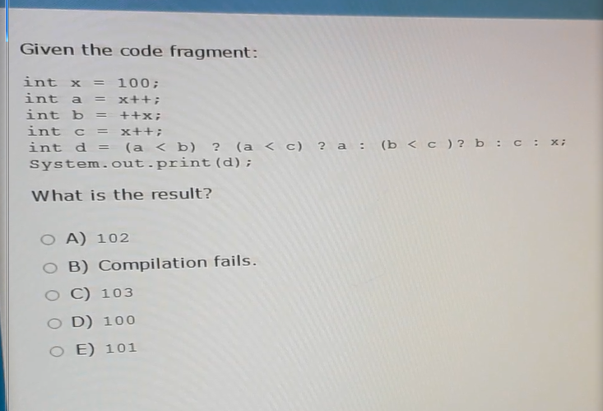

package vendorexam.que_7;

public class Test {

public static void main(String[] args) {

int x=100;

int a=x++;

int b=++x;

int c=x++;

int d=(a<b) ? (a<c)? a: (b<c) ? b : c : x ;

System.out.println(d);

}

}

Ans : D

Problem: 8

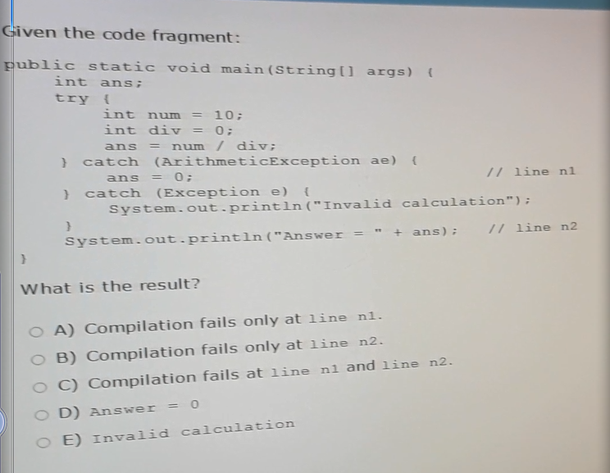

package vendorexam.que_8;

/**

*

* @author Touhid

*/

public class Test {

public static void main(String[] args) {

int ans;

try {

int num =10;

int div=0;

ans= num/div;

}

catch(ArithmeticExceptin ae){

ans=0; //line 1

}

catch (Exception e){

System.out.println("Invalid calculation");

}

System.out.println("Answere = " + ans); //line n2

}

// ans c

}

Ans: C

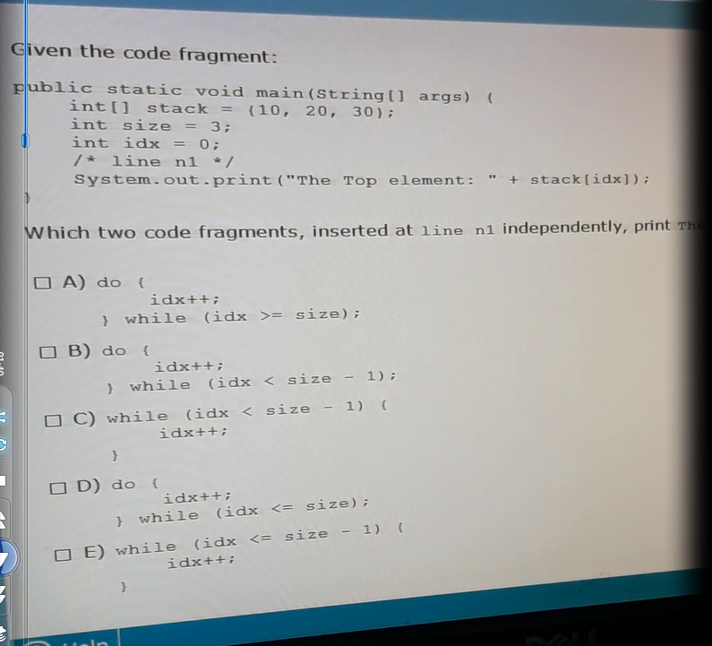Problem 9:

package vendorexam.que_9;

/**

*

* @author Touhid

*/

public class Test {

public static void main(String[] args) {

int[] stack ={10,20,30};

int size=3;

int idx=0;

//a

// do{

// idx++;

//

// }while(idx >= size-1);

// b

do{

idx++;

}while(idx < size-1);

// c

// while(idx<size-1){

// idx++;

// }

// d

// do{

// idx++;

//

// }while(idx <= size);

//e

// while(idx <= size-1){

// idx++;

// }

System.out.println("The Top Elememt: "+ stack[idx]);

}

}

Ans :BC

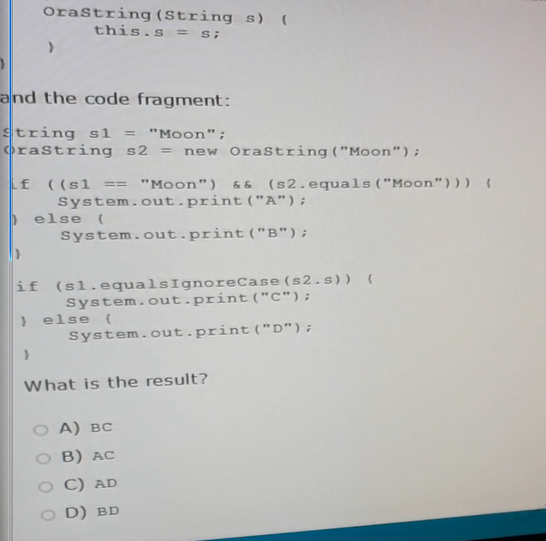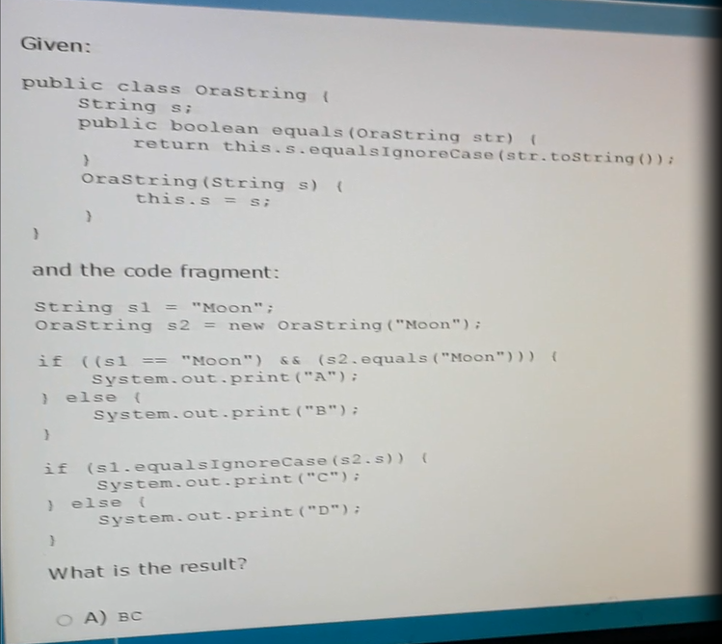Problem:10

package vendorexam.que_10;

/**

*

* @author Touhid

*/

public class OraString {

String s;

public boolean equals(OraString str){

return this.s.equalsIgnoreCase(str.toString());

}

public OraString(String s) {

this.s=s;

}

// Orastring(String s){

// this.s=s;

// }

public static void main(String[] args) {

String s1="Moon";

OraString s2 = new OraString("Moon");

if((s1=="Moon" && (s2.equals("Moon")))){

System.out.println("A");

}else{

System.out.println("B");

}

if(s1.equalsIgnoreCase(s2.s)){

System.out.println("C");

}else{

System.out.println("D");

}

}

}

Ans: A

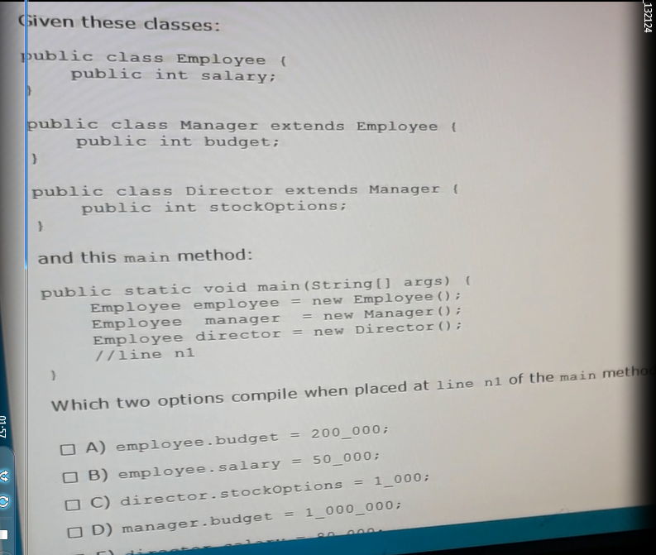Problem 11:

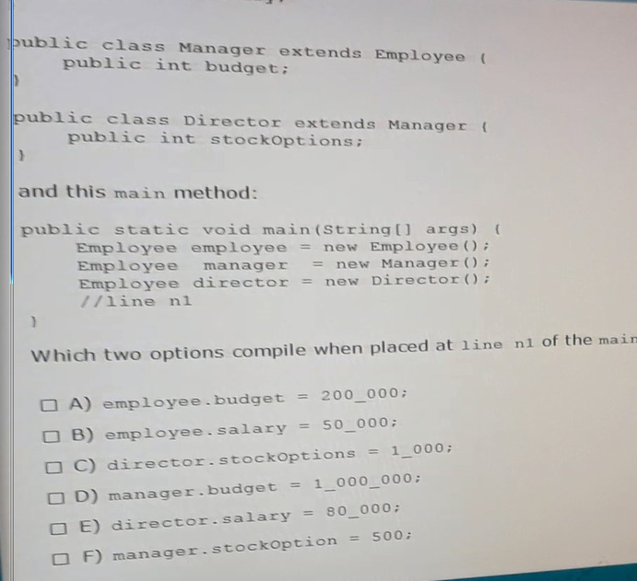

package vendorexam.que_11;

/**

*

* @author Touhid

*/

class Employee {

public int salary;

}

class Manager extends Employee {

public int budget;

}

class Director extends Manager{

public int stocoptions;

}

public class Test{

public static void main(String[] args) {

Employee employee=new Employee();

Employee manager=new Manager();

Employee director=new Director();

// employee.budget=200_000;

employee.salary=50_000;

//director.stocOptions=1_000;

//manager.budget=1_000_000;

director.salary=80_000;

// manager.stockOption=500;

}

//ans: be

}

Ans: BE

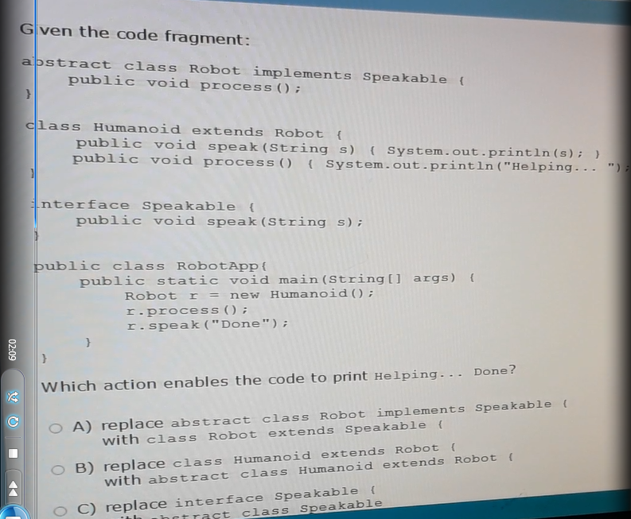Problem 12:

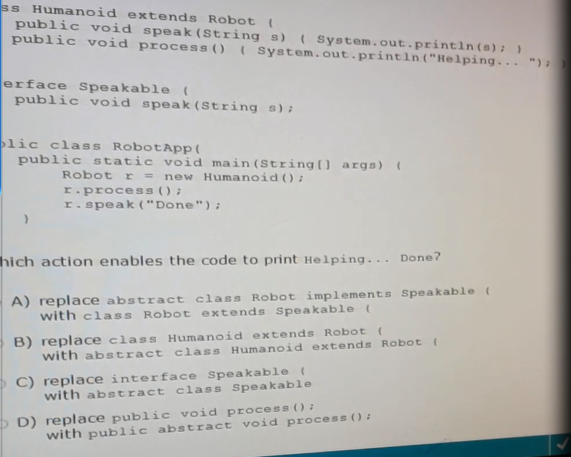

package vendorexam.que_12;

/**

*

* @author Touhid

*/

abstract class Robot implements Speakable{

//a/class Robot extends Speakable{

// public void process();

public abstract void process();

}

class Humanoid extends Robot{

//b/ abstract class Humanoid extends Robot{

public void speak(String s){

System.out.println(s);

}

@Override

public void process(){

System.out.println("Helping...");

}

}

interface Speakable{

//c/ abstract class Speakable{

public void speak(String s);

}

public class RobotApp {

public static void main(String[] args) {

Robot r=new Humanoid();

r.process();

r.speak("Done");

}

/// ans: d

}

Ans: D

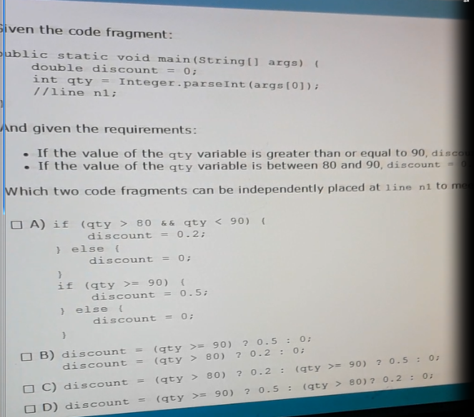Problem 13:

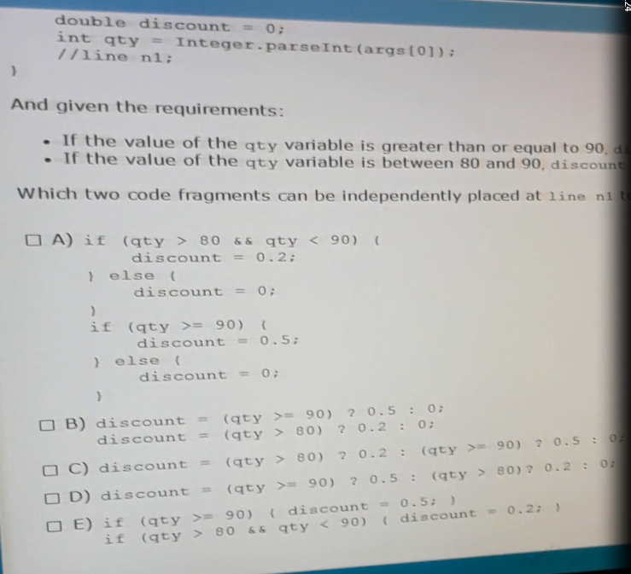

package vendorexam.que_13;

/**

*

* @author Touhid

*/

public class Test{

public static void main(String[] args) {

double discount=0;

int qty=Integer.parseInt(args[0]);

// line 1

// System.out.println(discount);

}

}Ans: AC

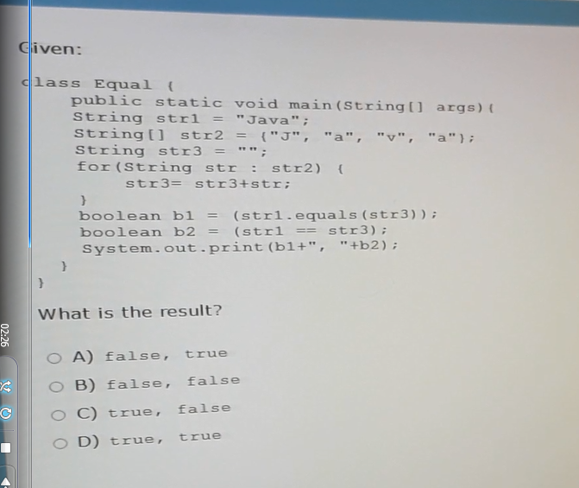Problem 14:

package vendorexam.que_14;

/**

*

* @author Touhid

*/

public class Equal {

public static void main(String[] args) {

String str1="Java";

String[] str2={"J", "b", "v", "a"};

String str3="";

for(String str : str2){

str3=str3+str;

}

boolean b1 = (str1.equals(str3));

boolean b2 =(str1==str3);

System.out.println(b1 + "," + b2);

}

}

Ans: B

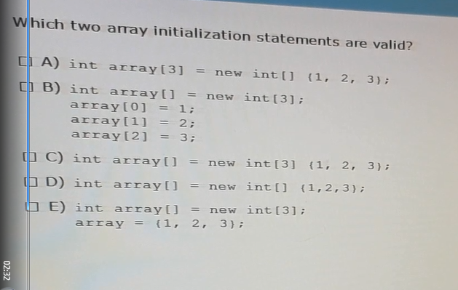Problem 15:

package vendorexam.que_15;

/**

*

* @author Touhid

*/

public class Test {

public static void main(String[] args) {

// a // int [] array[3]= new int[]{1,2,3};

//b

int array []=new int [3];

array[0]=1;

array[1]=2;

array[2]=3;

}

//c

// int array[]= new int[3] {1,2,3};

// d

// int array[]= new int[] {1,2,3};

// e

// int array[]= new int[3];

// array = {1, 2, 3};

//

}

//ans: b

Ans : B